Mop Simulation

*Software by the Dundee iGEM team is distributed under the terms of the GNU General Public License. GNU General Public License (hyperlink to the gpl-3.0.txt file)*

NetLogo is a multi-agent programmable modelling environment. Dundee iGEM Team used NetLogo as a tool to allow the visualisation of intracellular interactions within our bacterial mops and so to bring the dynamics to life. The aim was to create a simulation in which variables and characteristics can be altered, depending on the cells state, allowing us to observe the effect of such changes on the operation of the mop.

The wet team were utilising two pathways within the cell to transport Protein-Phosphatase 1 to the desired location. The sec system was used in both *E. coli* and *B. subtilis* while the tat system was implemented in *E. coli*. A full explanation of how these pathways work can be found here.

**Model 1 – Sec System in E. *coli***

Within this model, a scenario of our E. coli bacterial mop which utilised the sec protein-translocation pathway was analysed. The investigated section included the cytoplasm, inner & outer membranes, and the periplasm. Fig 1 shows how the world is set up and what the different agents represent.

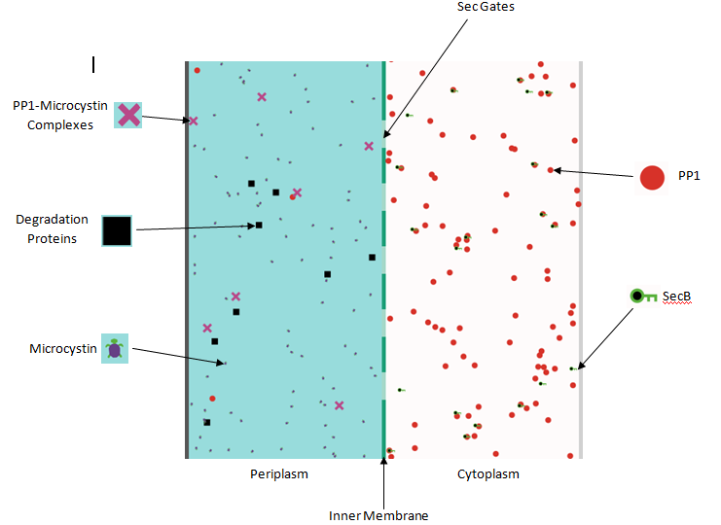

We have several mechanisms in place in order to accurately simulate the operation of our bacterial mop. These come in the form of:

1. Sliders
2. Switches
3. Input Controls
4. Counters
5. Graphs
6. **Sliders**

i. PP1 production

PP1 can be produced at a user-chosen rate from the right-side of the world (PP1-production slider). This is in simulation of PP1 from the rest of the cell entering our specific segment. Continuing this simulation, PP1 which encounters the right wall of the world is lost to the rest of the cell and so is removed in the simulation.

Although a similar system could be implemented for PP1 which encounters the upper and lower walls, we can simply assume that an equal number of molecules are lost to an equivalent segment above/below as enter the current segment. Thus, if a molecule of any kind encounters the top/bottom wall it will re-appear at the opposite wall (bottom/top respectively).

ii. Initial-PP1

The number of PP1 setup initially in the cytoplasm is controlled by the initial-PP1 slider, these are then placed at a set of random co-ordinates inside the cytoplasm.

iii. Initial-SecB

The initial number of secB proteins (shown as green keys) can be controlled by the initial-SecB slider. PP1 must bind to these proteins before they are allowed to enter the sec gate and become transported at the membrane.

The secB proteins cannot enter the periplasm.

iv. gate-size & gate-number

The sec gates have various alteration which can be made to them. The gate-size slider decides how wide each gate is and is measured in number of patches. The gate-number slider allows us to change how many gates are present in this segment of the cell. These gates are spaced an equal distance apart. Both of these properties allows us to predict how the cell could potentially work if the gates have different surface areas or if more gates were present in this area.

Once the PP1-secB complex reaches a gate, the PP1 passes into the periplasm and the secB protein is re-created in the cytoplasm and can be reused.

v. mc-production

Once in the periplasm, PP1 can then bind to microcystin. Microcystin is represented by small purple turtles which are produced (controlled by mc-production slider) at the left side (the cells outer membrane) and, like PP1, can leave the cell at the left but roll over to the top or bottom if they encounter those walls.

Microcystin cannot enter the cytoplasm.

vi. mc-number

There is also a slider to control the initial number of microcystin (mc-number) upon setup. These initial microcystin are, similarly to initial PP1, produced with a random position in the periplasm.

vii. degP-number

The black square agents represent degradation mechanisms. These degrade both PP1 and complexes which they encounter in the periplasm. An initial number of degradation mechanisms can be set up using the degP-number slider.

These cannot cross the inner or outer membranes but can roll over from top to bottom and vice versa.

Upon the binding of microcystin to PP1, the red circles representing PP1 become purple crosses called complexes. These represent the used PP1 molecules which has bound to a microcystin molecule. These cannot leave the cell or enter the cytoplasm but roll over from top to bottom and vice versa.

**2. Switches**

i. collide?

The collide? switch can be turned on or off and controls whether the different agents can collide and bounce off one another.

ii. random-walk

The random-walk switch activates/deactivates a random motion of the molecules in the simulation. When de-activated, the molecules move in the periplasm and cytoplasm with very simple kinetics in which the path taken assumes no collisions other than with the proteins discussed. The random-walk switch activation causes the randomisation of the propagation direction of the particles and so is an approximation to the Brownian motion which these particles would be expected to experience.

**3. Input Controls**

There are also 4 input controls which allow the user to control the probabilities of specific binding mechanisms. These are expressed in percentages and control the probability of;

1. secB proteins binding to PP1.
2. PP1-secB complex entering the sec gates
3. Degradation proteins degrading PP1 or the PP1-microcystin complexes
4. PP1 binding to microcystin
5. **Counters**

There are various counters in place to allow us to keep track of the numbers of our agents. These count the number of;

1. PP1 in the periplasm, on the left hand side.
2. PP1 in the cytoplasm, on the right hand side.
3. PP1 which has been transported and has gone through the sec machinery into the periplasm
4. PP1 which has microcystin bound to it – complexes
5. secB proteins in the cytoplasm
6. Degradation proteins in the periplasm
7. 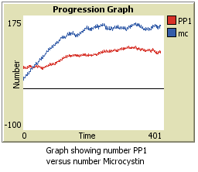**Graph**

The graph allows us to view the number of microcystin versus the number of PP1. PP1 is represented by a red line and microcystin by a blue line.

**Model 2 – Tat System in E. *coli***

Within this model, a scenario of our E. coli bacterial mop which utilised the twin-arginine translocation (tat) pathway was analysed. This system included the cytoplasm, inner & outer membranes, the periplasm, and the extracellular medium. Fig 2 shows how the world is set up and what the different agents represent.

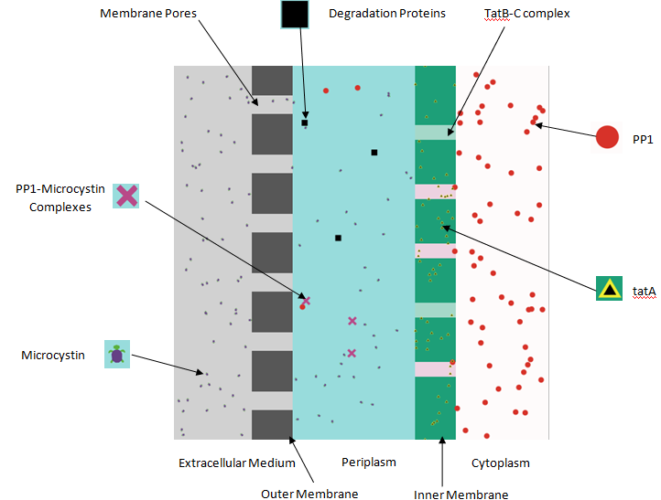

Similar to model 1, we have several mechanisms in place in order to accurately simulate the operation of our bacterial mop. These come in the form of:

1. Sliders
2. Switches
3. Input Controls
4. Counters
5. Graphs
6. **Sliders**

i. PP1 production

PP1 can be produced at a user-chosen rate from the right-side of the world (PP1-production slider). This is in simulation of PP1 from the rest of the cell entering our specific segment. Continuing this simulation, PP1 which encounters the right wall of the world is lost to the rest of the cell and so is removed in the simulation.

Although a similar system could be implemented for PP1 which encounters the upper and lower walls, we can simply assume that an equal number of molecules are lost to an equivalent segment above/below as enter the current segment. Thus, if a molecule of any kind encounters the top/bottom wall it will re-appear at the opposite wall (bottom/top respectively).

ii. Initial-PP1

The number of PP1 setup initially in the cytoplasm is controlled by the initial-PP1 slider, these are then placed at a set of random co-ordinates inside the cytoplasm.

iii. tatA-number

The initial number of tatA proteins (shown as yellow triangles) can be controlled by the tatA-number slider. PP1 must bind to these proteins in the inner membrane before they are allowed to enter the periplasm through the tatB-C complexes.

The tatA proteins cannot enter any other part of the cell other than the inner membrane.

iv. gate-size & gate-number

The tatB-C complexes have various alterations which can be made to them. The gate-size slider decides how wide each complex is and is measured in number of patches. The gate-number slider allows us to change how many complexes are present our segment of the cell. These complexes are spaced an equal distance apart. Both of these properties allow us to predict how the cell could potentially work if the tatB-C complexes have different surface areas or if more were present in this area.

Once the PP1 reaches a tatB-C complex, it remains halted there until the required amount of tatA’s are bound. The PP1 can then be transported into the periplasm and the tatA’s return to the membrane to be reused.

v. mc-production

Once in the periplasm, PP1 can then bind to microcystin. Microcystin is represented by small purple turtles (controlled by mc-production slider) which enter or exit the cell through pores in the outer membrane at the left side. Like PP1, they roll over to the top or bottom if they encounter those walls.

Microcystin cannot enter the cytoplasm.

vi. mc-number

There is also a slider to control the initial number of microcystin (mc-number) upon setup. These initial microcystin are, similarly to initial PP1, produced with a random position in the **periplasm**.??

vii. degP-number

The black square agents represent degradation mechanisms. These degrade both PP1 and complexes which they encounter in the periplasm. An initial number of degradation mechanisms can be set up using the degP-number slider.

These cannot cross the inner or outer membranes but can roll over from top to bottom and vice versa.

viii. tatA-required

This slider allows the user to alter the number of tatA proteins needed to bind to PP1, in the inner cell membrane, allowing PP1 to be transported.

ix. pore-number & pore-size

The pores in the outer membrane have various alterations which can be made to them. The pore-size slider decides how wide each pore is and is measured in number of patches. The pore-number slider allows us to change how many pores are present in this segment of the cell. These pores are spaced an equal distance apart. Both of these properties allow us to predict how the cell could potentially work if the pores have different surface areas or if more were present in this area.

Upon the binding of microcystin to PP1, the red circles representing PP1 become purple crosses called complexes. These represent the used PP1 molecules which has bound to a microcystin molecule. These cannot leave the cell or enter the cytoplasm but roll over from top to bottom and vice versa.

**2. Switches**

i. collide?

The collide? switch can be turned on or off and controls whether the different agents can collide and bounce off one another.

ii. random-walk

The random-walk switch activates/deactivates a random motion of the molecules in the simulation. When de-activated, the molecules move in the periplasm, cytoplasm , and extracellular medium with very simple kinetics in which the path taken assumes no collisions other than with the proteins discussed. The random-walk switch activation causes the randomisation of the propagation direction of the particles and so is an approximation to the Brownian motion which these particles would be expected to experience.

**3. Input Controls**

There are also 4 input controls which allow the user to control the probabilities of specific binding mechanisms. These are expressed in percentages and control the probability of;

1. tatA proteins binding to PP1.
2. PP1 binding to the tatB-C complexes.
3. Degradation proteins degrading PP1 or the PP1-microcystin complexes
4. PP1 binding to microcystin
5. **Counters**

There are various counters in place to allow us to keep track of the numbers of our agents. These count the number of;

i. PP1 in the periplasm, in the middle.

ii. PP1 in the cytoplasm, on the right hand side.

iii. PP1 which has been transported and has gone through the tat machinery into the periplasm

iv. PP1 which has microcystin bound to it – complexes

v. Degradation proteins in the periplasm

**5. Graph**

The graph allows us to view the number of microcystin versus the number of PP1. PP1 is represented by a red line and microcystin by a blue line.